**1. Project Name:** Git Fighter

**2. Group Information:**

Member 1:

Pavankumar Bhadane

[pavankumar.bhadane20@vit.edu](mailto:pavankumar.bhadane20@vit.edu)

CS - C

12010226

Member 2:

Shreya Roy

[shreya.roy20@vit.edu](mailto:shreya.roy20@vit.edu)

E&TC - D

12010171

Member 3:

Shubham Shah

[shubham.shah20@vit.edu](mailto:shubham.shah20@vit.edu)

CS - D

12010796

**3. Project GitHub Link:** https://github.com/suhas-kadu/robospark-2021-FT-Git_Fighter.git

**4. Project Workflow:**

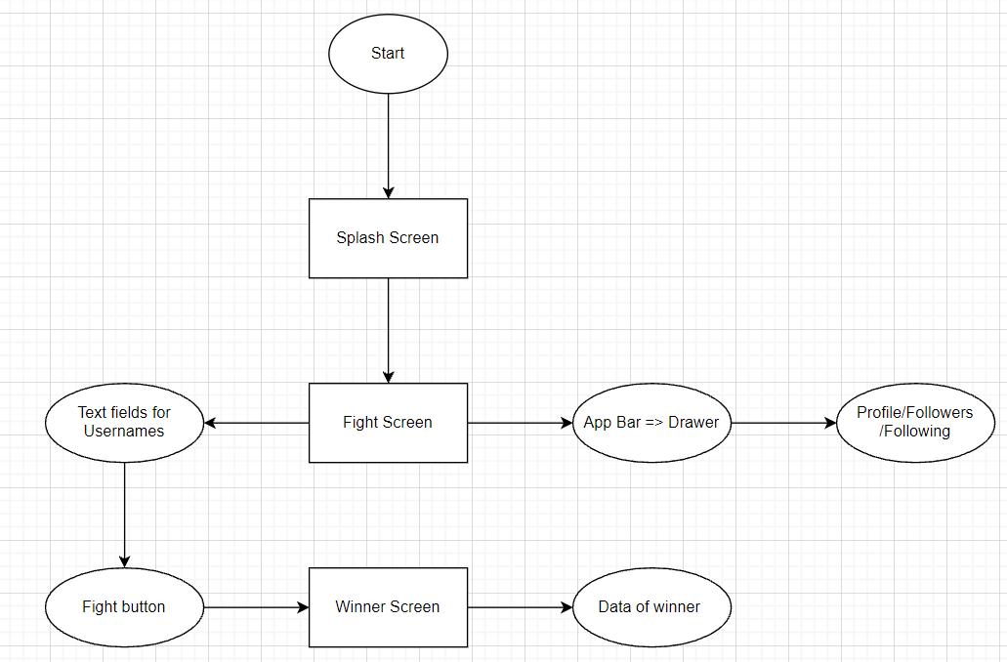  
 Fig. 01 App Workflow

**5. Problems Faced:**

* Learning everything on our own and implementing them the right way took time.
* Use of GitHub for pushing the code to our respective branches was quite new for us.
* Visual Studio took a long time to build the project on the mobile emulator every time.
* We were facing a glitch in the winner screen.

**6. Alternative Solutions found for problems mentioned above:**

* We referred to Dr.Angela’s playlist on Udemy for learning flutter.
* Our mentor taught us how to use features of Github not known to us in projects.
* Some of the features to be merged later were implemented individually and run on Chrome which saved time.
* We removed the glitch in the winner screen by referring to stack overflow.

**7. Code snippet ss:**

**Main.dart :**

**import 'package:flutter/cupertino.dart';**

**import 'package:flutter/material.dart';**

**import 'package:git_fighter/screens/splash_screen.dart';**

**void main() => runApp(MyApp());**

**class MyApp extends StatelessWidget {**

**@override**

**Widget build(BuildContext context) {**

**return MaterialApp(**

**debugShowCheckedModeBanner: false,**

**title: 'Git Fighter',**

**theme: ThemeData(**

**brightness: Brightness.dark, primaryColor: Colors.yellowAccent),**

**darkTheme: ThemeData.dark(),**

**home: SplashScreen());**

**}**

**}**

Splash Screen Code:

import 'dart:async';

import 'package:flutter/material.dart';

import 'package:font_awesome_flutter/font_awesome_flutter.dart';

import 'fight_screen.dart';

class SplashScreen extends StatefulWidget {

@override

_SplashScreenState createState() => _SplashScreenState();

}

class _SplashScreenState extends State<SplashScreen> {

@override

void initState() {

super.initState();

Timer(Duration(seconds: 5), () {

Navigator.pushReplacement(context,

MaterialPageRoute(builder: (BuildContext context) => FightScreen()));

});

}

@override

Widget build(BuildContext context) {

return Scaffold(

body: Stack(

fit: StackFit.expand,

children: [

Container(

decoration: BoxDecoration(color: Colors.white),

),

Column(

mainAxisAlignment: MainAxisAlignment.start,

children: [

Expanded(

flex: 2,

child: SingleChildScrollView(

child: Column(

mainAxisAlignment: MainAxisAlignment.center,

children: [

CircleAvatar(

backgroundColor: Colors.white,

radius: 150.0,

child: FaIcon(

FontAwesomeIcons.githubSquare,

size: 140.0,

color: Colors.black,

),

),

Padding(

padding: EdgeInsets.only(top: 10.0),

),

Text(

"Git Fighter",

style: TextStyle(

color: Colors.grey[900],

fontSize: 34.0,

fontWeight: FontWeight.bold),

)

],

),

),

),

Expanded(

flex: 1,

child: Column(

mainAxisAlignment: MainAxisAlignment.center,

children: [

Text(

"By TRF Team Flutter",

style: TextStyle(

color: Colors.grey[900],

fontSize: 24.0,

fontWeight: FontWeight.bold),

// Padding(padding: EdgeInsets.only(top: 10))

)

],

))

],

),

],

),

);

}

}

Fight Screen code:

import 'dart:convert';

import 'package:flutter/material.dart';

import 'package:git_fighter/screens/winner_screen.dart';

import 'package:http/http.dart' as http;

class FightScreen extends StatefulWidget {

@override

_FightScreenState createState() => _FightScreenState();

}

class _FightScreenState extends State<FightScreen> {

final TextEditingController txtUser1Controller = TextEditingController();

final TextEditingController txtUser2Controller = TextEditingController();

String winner;

var responseUser1, responseUser2;

@override

Widget build(BuildContext context) {

return Scaffold(

appBar: AppBar(

title: Text('Git Fighter'),

),

drawer: Drawer(

child: Column(

children: [

Container(

width: double.infinity,

padding: EdgeInsets.all(20),

color: Colors.grey[800],

child: Center(

child: Column(

children: [

Container(

width: 100,

height: 100,

margin: EdgeInsets.only(top: 30, bottom: 10),

decoration: BoxDecoration(

shape: BoxShape.circle,

image: DecorationImage(

image: NetworkImage(

'https://avatars.githubusercontent.com/u/90468365?s=400&u=b7c419ea83147ff256e2902208183cd7401c2aa2&v=4'),

fit: BoxFit.fill),

)),

Text(

'Pavan Bhadane',

style: TextStyle(fontSize: 22, color: Colors.white),

),

Text(

'pavan49719@gmail.com',

style: TextStyle(fontSize: 15, color: Colors.white),

),

],

),

),

),

Container(

width: double.infinity,

padding: EdgeInsets.all(20),

color: Colors.grey[700],

child: Center(

child: Text(

'Follwers: 48',

style: TextStyle(fontSize: 20, color: Colors.white),

)),

),

Container(

width: double.infinity,

padding: EdgeInsets.all(20),

color: Colors.grey[700],

child: Center(

child: Text(

'Follwing: 21',

style: TextStyle(fontSize: 20, color: Colors.white),

)),

),

Container(

width: double.infinity,

padding: EdgeInsets.all(20),

color: Colors.grey[700],

child: Center(

child: Text(

'Repos : 11',

style: TextStyle(fontSize: 20, color: Colors.white),

)),

)

],

),

),

body: Center(

child: Padding(

padding: EdgeInsets.all(10),

child: SingleChildScrollView(

child: Column(

mainAxisAlignment: MainAxisAlignment.start,

children: [

SizedBox(height: 60),

const Text(

'Git Fighter',

style: TextStyle(

color: Colors.greenAccent,

fontSize: 60,

fontWeight: FontWeight.bold,

),

textAlign: TextAlign.center,

),

SizedBox(height: 90),

TextField(

controller: txtUser1Controller,

decoration: InputDecoration(

border: OutlineInputBorder(),

labelText: 'User 1',

hintText: 'Enter username'),

),

SizedBox(height: 60),

InkWell(

onTap: () {

startFight();

},

borderRadius: BorderRadius.circular(20),

// hoverColor: Colors.indigoAccent[200],

child: Container(

clipBehavior: Clip.antiAlias,

alignment: Alignment.center,

width: 120,

height: 120,

decoration: BoxDecoration(

borderRadius: BorderRadius.circular(60),

color: Colors.indigoAccent,

),

child: Row(

mainAxisAlignment: MainAxisAlignment.center,

children: [

Image.asset(

'images/fight.png',

width: 120,

height: 120,

alignment: Alignment.center,

fit: BoxFit.contain,

),

]),

),

),

SizedBox(height: 60),

TextField(

controller: txtUser2Controller,

decoration: InputDecoration(

border: OutlineInputBorder(),

labelText: 'User 2',

hintText: 'Enter username'),

),

SizedBox(height: 90),

Container(

alignment: Alignment.topLeft,

width: 2000.0,

height: 6.0,

color: Colors.greenAccent,

),

SizedBox(height: 20),

Container(

alignment: Alignment.topLeft,

width: 2000.0,

height: 6.0,

color: Colors.greenAccent,

)

],

),

))),

);

}

void startFight() async {

if (txtUser1Controller.text == "" ||

txtUser2Controller.text == "" ||

txtUser1Controller.text == null ||

txtUser2Controller.text == null) {

// createAlertDialog(context);

ScaffoldMessenger.of(context).showSnackBar(SnackBar(

content: Text("Please enter username"),

));

} else {

responseUser1 = await http

.get(Uri.http('api.github.com', 'users/${txtUser1Controller.text}'));

responseUser2 = await http

.get(Uri.http('api.github.com', 'users/${txtUser2Controller.text}'));

var jsonData1 = jsonDecode(responseUser1.body);

var jsonData2 = jsonDecode(responseUser2.body);

if (jsonData1["message"] == "Not Found" ||

jsonData2["message"] == "Not Found") {

ScaffoldMessenger.of(context).showSnackBar(SnackBar(

content: Text("Enter valid username"),

));

} else {

int user1Followers = jsonData1['followers'];

int user2Followers = jsonData2['followers'];

int user1Following = jsonData1['following'];

int user2Following = jsonData2['following'];

setState(

() {

if ((user1Followers + user1Following) >

(user2Followers + user2Following))

winner = txtUser1Controller.text;

else

winner = txtUser2Controller.text;

print("winner is $winner");

Navigator.push(

context,

MaterialPageRoute(

builder: (BuildContext context) => Winner(winner),

),

);

},

);

}

}

}

}

**Winner Screen Code:**

**import 'dart:convert';**

**import 'package:flutter/material.dart';**

**import 'package:git_fighter/models/winner_data.dart';**

**import 'package:git_fighter/widget/all_confetti_widget.dart';**

**import 'package:http/http.dart' as http;**

**class Winner extends StatefulWidget {**

**String winner;**

**Winner(String winner) {**

**this.winner = winner;**

**}**

**@override**

**_WinnerState createState() => _WinnerState(winner);**

**}**

**class _WinnerState extends State<Winner> {**

**WinnerData winnerData = new WinnerData();**

**String winner;**

**_WinnerState(String winner) {**

**this.winner = winner;**

**}**

**@override**

**void initState() {**

**super.initState();**

**getProfileData();**

**setState(() {});**

**}**

**void getProfileData() async {**

**var response = await http.get(Uri.http('api.github.com', 'users/$winner'));**

**var jsonData = await jsonDecode(response.body);**

**setState(() {**

**winnerData = WinnerData.fromJson(jsonData);**

**});**

**}**

**@override**

**Widget build(BuildContext context) {**

**return Scaffold(**

**appBar: AppBar(**

**centerTitle: true,**

**title: Center(child: Text("Winner : $winner ")),**

**),**

**body: Center(**

**child: (SingleChildScrollView(**

**child: Padding(**

**padding: const EdgeInsets.all(10.0),**

**child: Column(**

**crossAxisAlignment: CrossAxisAlignment.stretch,**

**mainAxisAlignment: MainAxisAlignment.start,**

**children: <Widget>[**

**AllConfettiWidget(),**

**SizedBox(height: 20),**

**Container(**

**height: 200.0,**

**width: 200.0,**

**child: winnerData.avatarUrl != null**

**? CircleAvatar(**

**backgroundImage:**

**NetworkImage("${winnerData.avatarUrl}"),**

**radius: 20,**

**backgroundColor: Colors.transparent,**

**foregroundColor: Colors.transparent,**

**)**

**: Container(),**

**),**

**Padding(**

**padding: EdgeInsets.fromLTRB(10, 0, 0, 0),**

**),**

**Text(**

**"Followers : ${winnerData.followers}",**

**style: TextStyle(fontSize: 30),**

**textAlign: TextAlign.center,**

**),**

**Text(**

**"Following : ${winnerData.following}",**

**style: TextStyle(fontSize: 30),**

**textAlign: TextAlign.center,**

**),**

**SizedBox(height: 20),**

**Container(**

**alignment: Alignment.topLeft,**

**width: 2000.0,**

**height: 6.0,**

**color: Colors.blueAccent,**

**),**

**SizedBox(height: 20),**

**Text(**

**"Repos : ${winnerData.publicRepos}",**

**style: TextStyle(fontSize: 24),**

**),**

**SizedBox(height: 20),**

**winnerData.bio != null**

**? Text(**

**"Bio : ${winnerData.bio}",**

**style: TextStyle(**

**fontSize: 24,**

**),**

**)**

**: Container(),**

**Padding(**

**padding: EdgeInsets.only(top: 30),**

**),**

**winnerData.company != null**

**? Text(**

**"Company : " "${winnerData.company}",**

**style: TextStyle(**

**fontSize: 24,**

**),**

**)**

**: Container(),**

**Padding(**

**padding: EdgeInsets.only(top: 30),**

**),**

**winnerData.location != null**

**? Text(**

**"Location : " "${winnerData.location}",**

**style: TextStyle(**

**fontSize: 24,**

**),**

**)**

**: Container(),**

**Padding(**

**padding: EdgeInsets.only(top: 30),**

**),**

**Container(**

**alignment: Alignment.topLeft,**

**width: 2000.0,**

**height: 6.0,**

**color: Colors.blueAccent,**

**),**

**],**

**),**

**),**

**)),**

**),**

**);**

**}**

**}**

**Animation Code:**

**import 'dart:math';**

**import 'package:confetti/confetti.dart';**

**import 'package:flutter/material.dart';**

**import 'package:confetti/src/enums/confetti_controller_state.dart';**

**class AllConfettiWidget extends StatefulWidget {**

**const AllConfettiWidget({**

**Key key,**

**}) : super(key: key);**

**@override**

**_AllConfettiWidgetState createState() => _AllConfettiWidgetState();**

**}**

**class _AllConfettiWidgetState extends State<AllConfettiWidget> {**

**ConfettiController controller;**

**@override**

**void initState() {**

**super.initState();**

**controller = ConfettiController(duration: Duration(seconds: 5));**

**controller.play();**

**}**

**static final double right = 0;**

**static final double down = pi / 2;**

**static final double left = pi;**

**static final double top = -pi / 2;**

**final double blastDirection = left;**

**@override**

**Widget build(BuildContext context) {**

**return GestureDetector(**

**behavior: HitTestBehavior.opaque,**

**onTap: () {**

**if (controller.state == ConfettiControllerState.playing) {**

**controller.stop();**

**} else {**

**controller.play();**

**}**

**},**

**child: Stack(**

**children: [**

**buildConfetti(),**

**],**

**),**

**);**

**}**

**Widget buildConfetti() => Align(**

**alignment: Alignment.center,**

**child: ConfettiWidget(**

**confettiController: controller,**

**colors: [**

**Colors.red,**

**Colors.blue,**

**Colors.orange,**

**Colors.purple,**

**Colors.lightBlue,**

**],**

**//blastDirection: blastDirection,**

**blastDirectionality: BlastDirectionality.explosive,**

**shouldLoop: true,**

**emissionFrequency: 0.05,**

**numberOfParticles: 5,**

**gravity: 0.2,**

**maxBlastForce: 2,**

**minBlastForce: 1,**

**particleDrag: 0.1,**

**),**

**);**

**}**

**8. Output:**

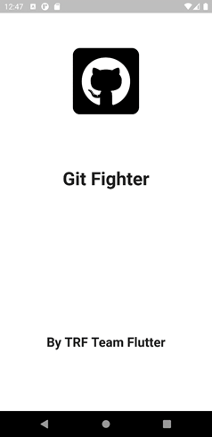 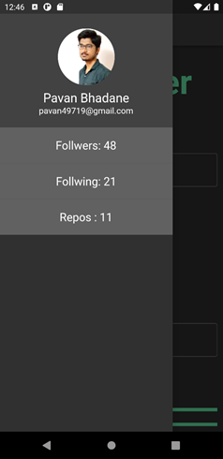  
 Fig. 02: Splash Screen Fig. 03: Drawer

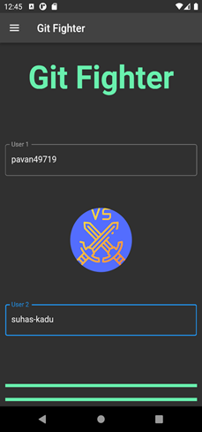 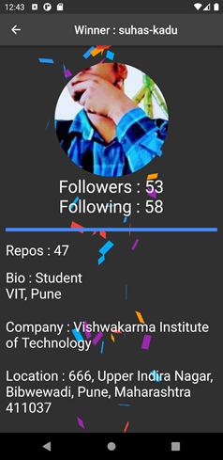  
 Fig. 04: Fight Screen Fig. 05: Winner Screen